Introduction to Deep Learning Notes
Christopher Kalitin

MIT Introduction to Deep Learning
MIT Introduction to Deep Learning | 6.S191
http://introtodeeplearning.com/2020/index.html

Watch videos on vectors & dot products. & Matmul.
Calculus Required
Element Wise Multiplication.
Mean & Standard Variation Vectors

Deep learning is in the subset of machine learning.
Machine learning used to search for hand engineered features. Eg. edges. Now, search for patterns.
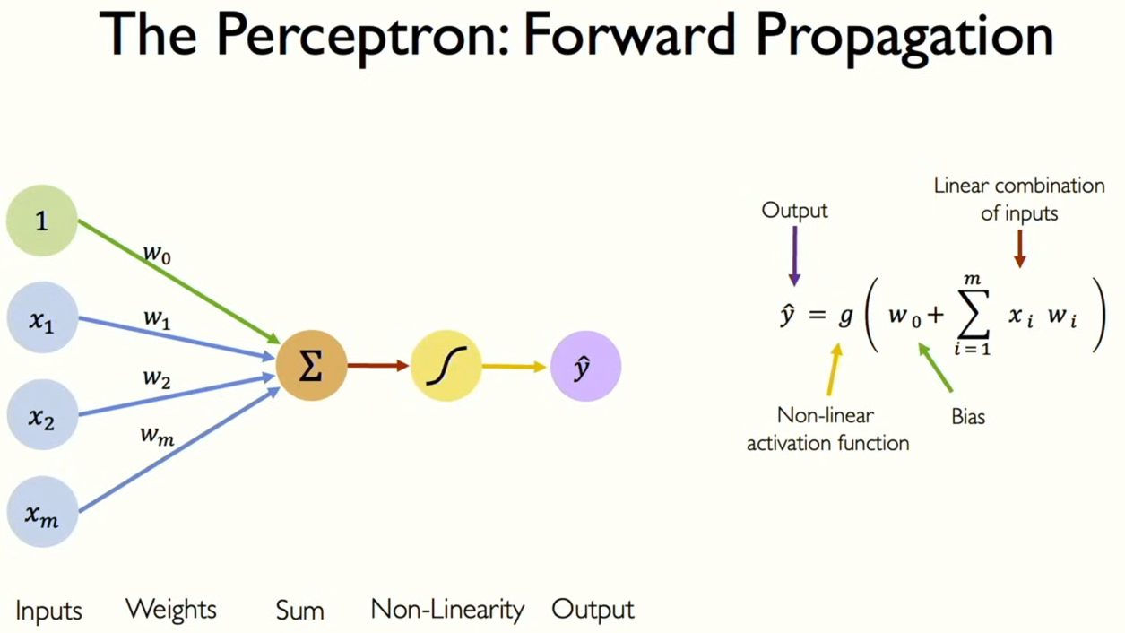
Perceptrons:
- It is a single neuron w/ many inputs & weights
- Pass the sum to a non-linear activation function
- The bias shifts the activation func. on the x-axis
- Sigmoid function is a common activation func.
- “Linear functions combined with linear functions are still linear.”
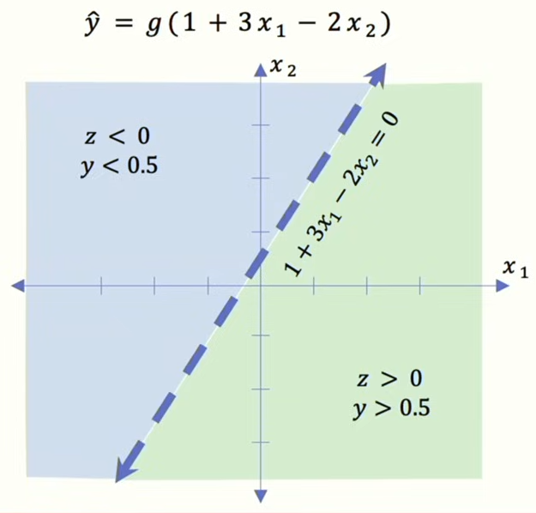
- Non-linear functions are needed to sort datasets that are non-linear (imagine coloured points on graph)
- Dot product -> Add Bias -> Apply Non-linearity
- Plot the line of the weights & bias, you can get the sign by which side your point is on, then with the activation function you get the output value.
- This is the feature space (chart)

- Dense Layer: Between inputs & neurons, ie. the weights.
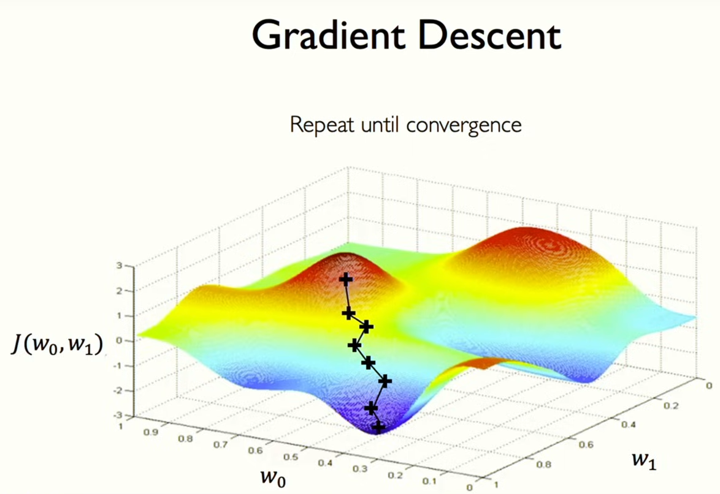
- Deep Neural Net: Many layers <- It’s simple
- Loss Function: Difference between predicted value (output) and ground truth (actual value, eg. test set)

Gradient Descent:
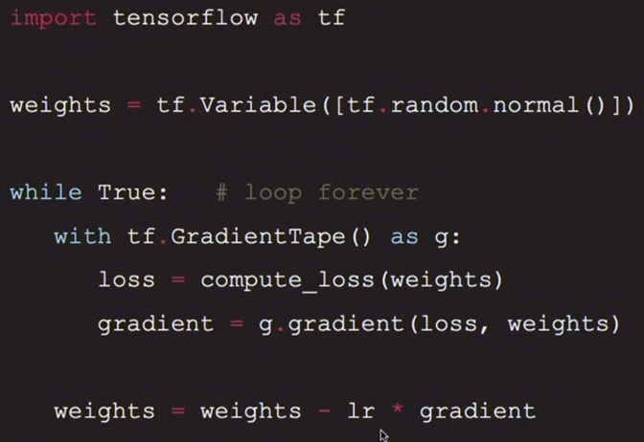
- Pick a random point (axis are weights), compute the gradient (which direction has a less wrong output), step, repeat.
- Learning Rate: The small step you take in the direction of less loss.

Back Propagation: Used to determine the gradient
Simply the process of changing a weight and finding the difference in loss.
Calculus Required

Setting the Learning Rate: Too small, you get stuck in local minima and converge slowly. Too large, overshoot and diverge.

Stochastic Gradient Descent takes a batch of data points (instead of all of them in the dataset) and calculates the gradient at these points. It’s noisy because you’re almost never exactly at that point. Parallelizable.

Increased speed and increased accuracy of the gradients allows for faster convergence.

Regularization: Constrain the optimization, discourage complex models. Overfitting.

Dropout Regularization: Randomly set some activations (neurons / perceptrons) to 0. Dynamically lower Neural Net capacity, it learns different pathways to find the correct output.

Early Stopping Regularization: Overfitting is when the model starts to perform worse on the test set. Stop when this happens. Stop at the point between under-fitting and overfitting.

Deep Sequence Modeling - Recurrent Neural Networks, Transformers, and Attention
MIT 6.S191: Recurrent Neural Networks, Transformers, and Attention

Sequential Data: Just a sequence of data, eg. position, text, audio. Either forward or backward, eg. input is a sequence or output is generating a sequence.
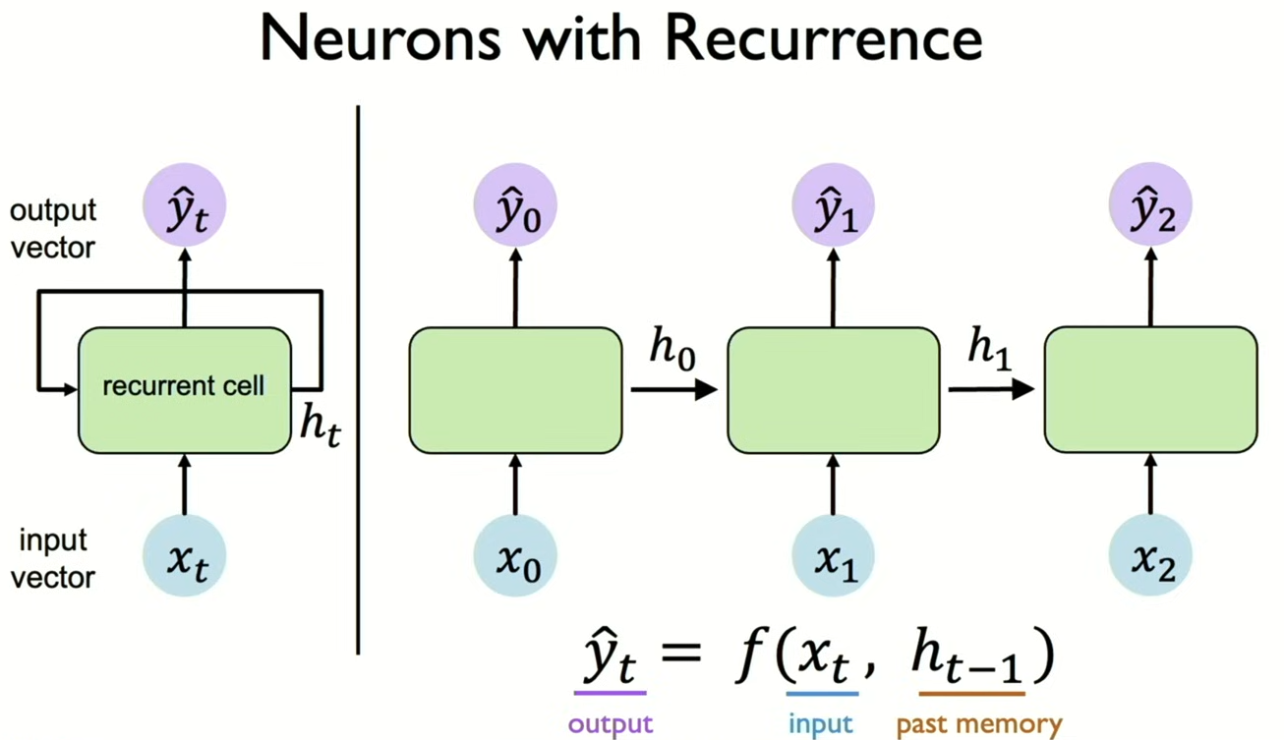
Recurrence cell/neuron: The output is a function of both the model output and a variable from the previous computation (hidden state). The hidden state can be a list of weights.

The RNN is itself a layer.

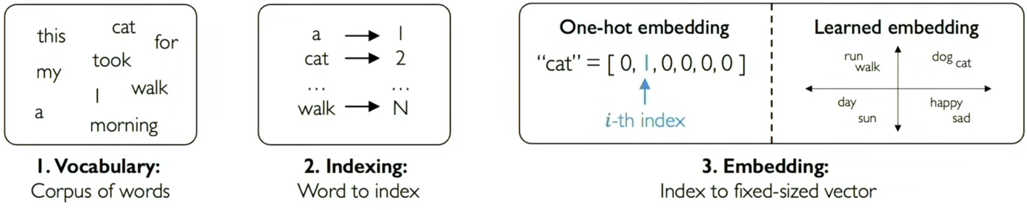
Language/data must be encoded in some way. Embedding is indexing the list of all words or grouping similar words together. Memory is needed for context. There is a trade-off in the size of the embedding space, not too big to be like one-hot, not too small to not be useful.

Backpropagation through Time: Go backwards through each NN step from the net output. Then, backwards again through time.

Long Short Term Memory (LSTM) networks gate certain recurrent units so that context is applied in a better way.

RNN bottlenecks: Hidden state size limits the context - low long-term memory capacity, no parallelization.

Attention addresses the bottlenecks by specifying what data is important. Extract the most important parts of the input. Transformers are built on attention as their fundamental mechanism.
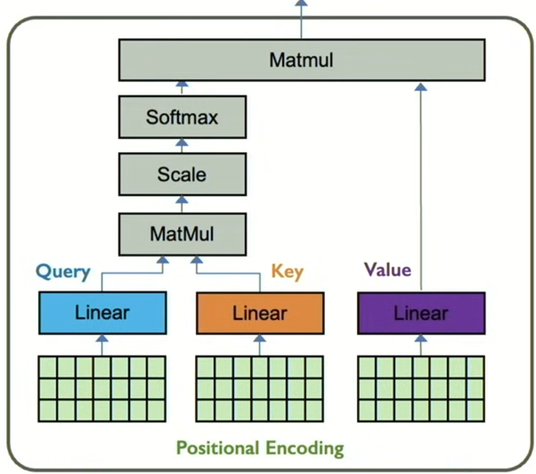
TRANSFORMERS

Attention example: search queries. Query, Key, Value.
Attention doesn’t use timesteps, but needs to encode position information.
With the positional embedding, the query, key, and value are all extracted by separate Neural Net learned linear layers. Attention is the similarity between the query and key. With the attention weights and value, multiply to get output.

Softmax: put variables between 0 and 1.

Deep Computer Vision - Convolutional Neural Networks
MIT 6.S191: Convolutional Neural Networks

Two types of Computer Vision:
- Regression: Output variable is a continuous value. Continuous.
- Classification: Output variable takes class label w/ Probability. Discrete.
Classification is done by high level feature detection, ie. patterns.
Learn a hierarchy of features.
Shrinking two dimensional data into a single layer of a Fully Connected Neural Net (it’s simple), removes all the geometric structure. You need to use a spatial structure as input to a NN.

You can connect patches of pixels (eg. 4x4) to a single neuron, then overlap the patches. This is a Convolutional Filter. Apply a filter (set of weights) on the input pixels, then shift the convolutional filter 2 pixels over, repeat. Use multiple filters to extract different features. The output is a feature map.

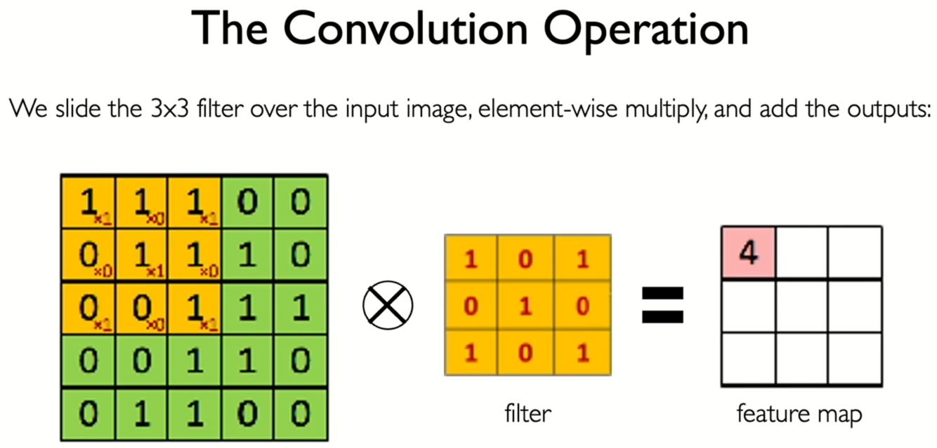
Element Wise Multiplication.
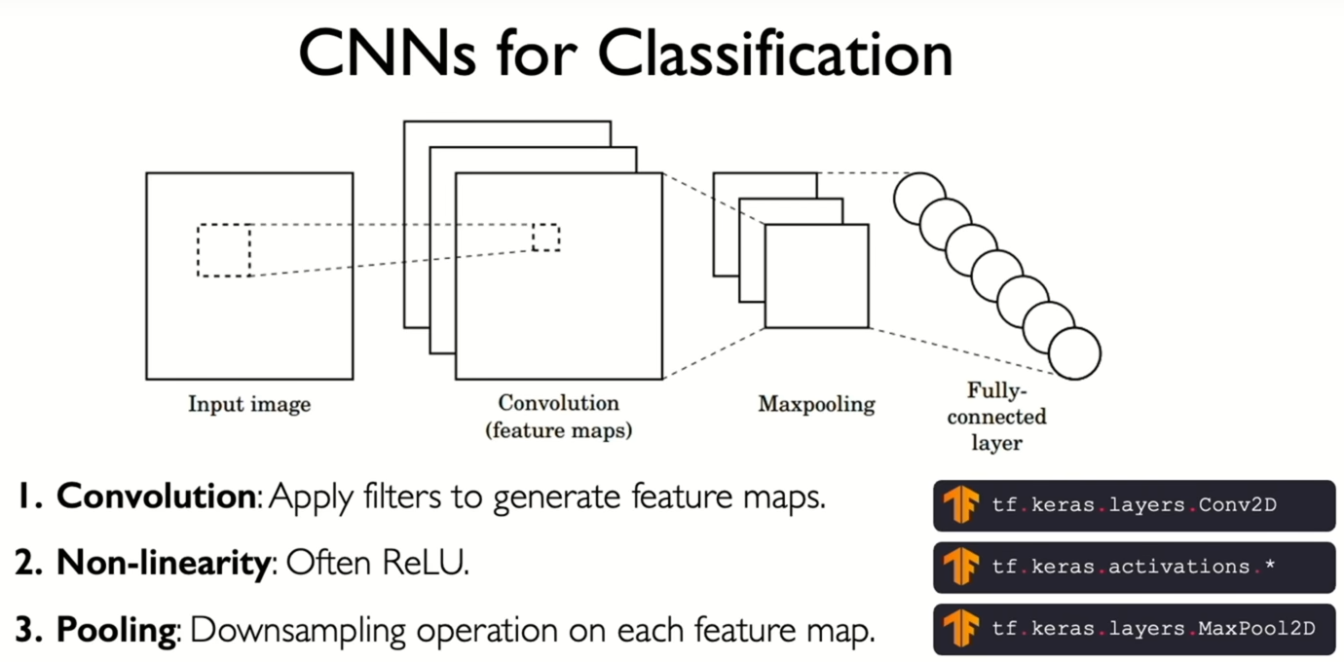

Stride: Step size of convolution filter. Higher stride = smaller conv. output.
Convolution Output Volume: Each conv. layer can detect many features, so your output is width*height*depth. Depth = number of filters.
Pooling: Shrinking filters. Eg. Max pooling (take max of each 2x2 pixel area)
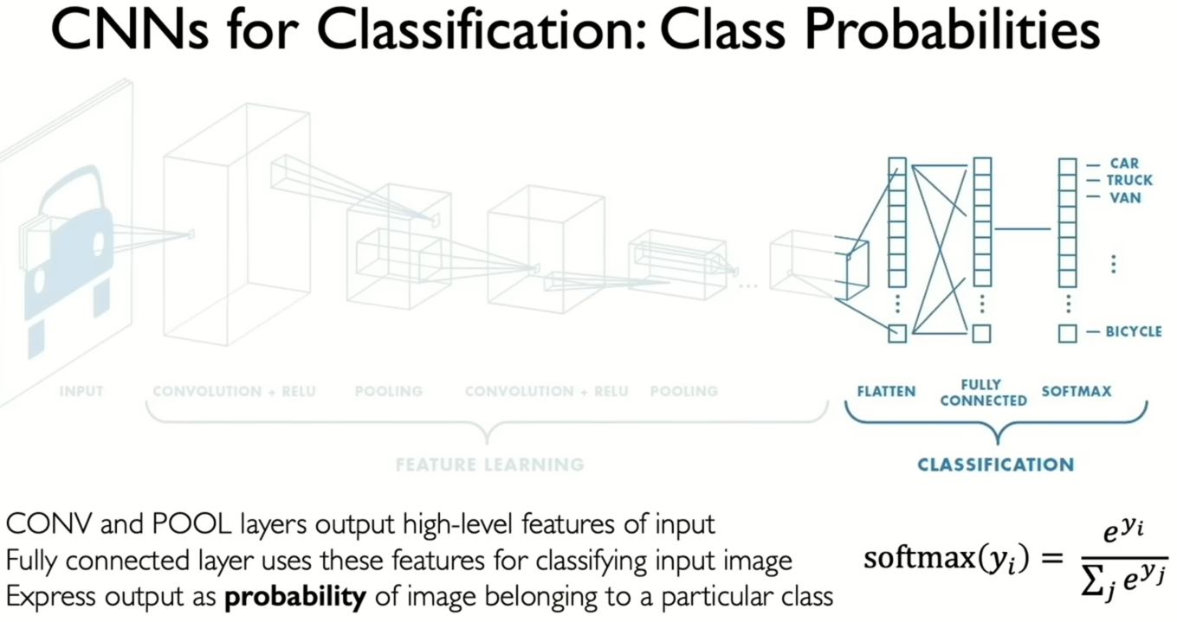
CNNs are used for classification by first extracting features, then classifying and applying a softmax step at the end to get probabilities.

A Regional Proposal Network can be used to learn which parts of an image could contain features. Ie. where is the taxi in the image.

CNNs learn features/weights through back propagation, not through human definition. Ie. end to end.

CNNs can function as RNNs by inputting the extracted features from the current step into the next step.

Deep Generative Modeling
MIT 6.S191: Deep Generative Modeling

A lot more math is required to gain a full understanding of this section.

Supervised Learning: Learn to find labels for data, human test set? Eg. Classification, regression, object detection, semantic segmentation, etc.
Unsupervised Learning: Input data with no labels, learn hidden or underlying structure of the data.

A Latent Variable is an underlying variable that drives the observation. Vs. Observed Variables. Generative/Latent Variable Models try to learn these underlying variables.
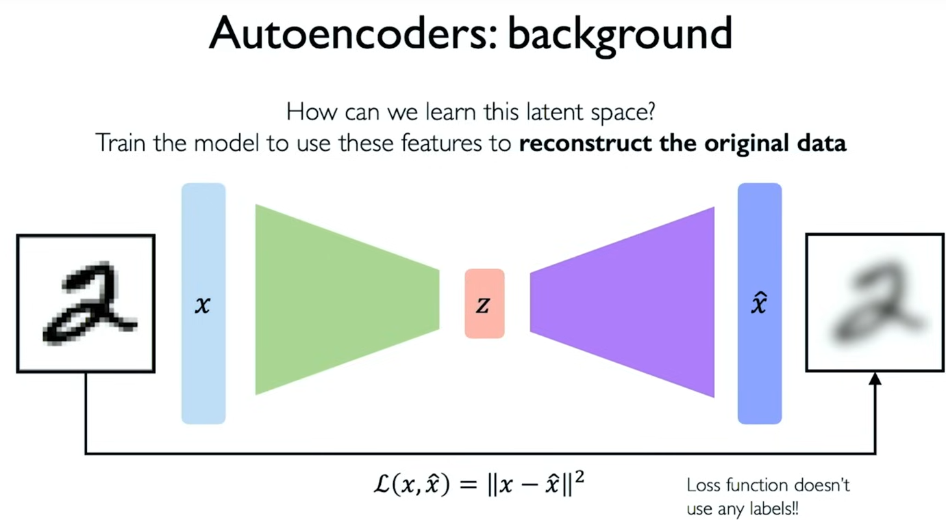
Latent Variable Models:
- Autoencoders:
Autoencode the input to get into a lower dimensional Latent Space, then decode back out to the original data space.
Tradeoff between quality of output and size of latent space. Automatically encoding data.
- Variational Autoencoders (VAEs):
In the latent layer, introduce randomness?
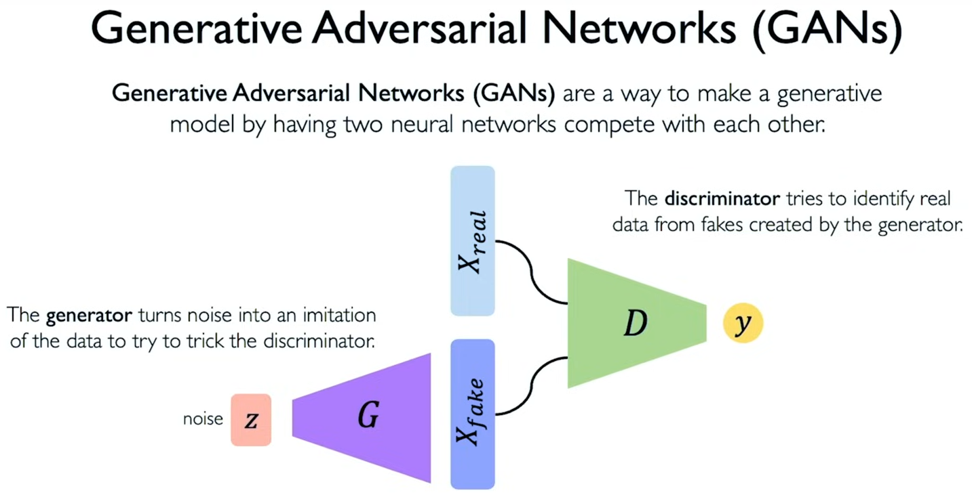
Mean & Standard Variation Vectors
- Generative Adversarial Networks (GANs):
Use the generator to create imitation data from noise. The discriminator tries to identify real data from generated data, they are trained together.
The Discriminator is a classifier model.
Cycle GANs transform one piece of data into another (instead of noise to data). Eg. horse video to zebra video. Obama Video.

Deep Reinforcement Learning
MIT 6.S191: Reinforcement Learning

Reinforcement learning is unsupervised, opposite of what we’ve seen so far.
State-action pairs. No data or labels like previous methods.

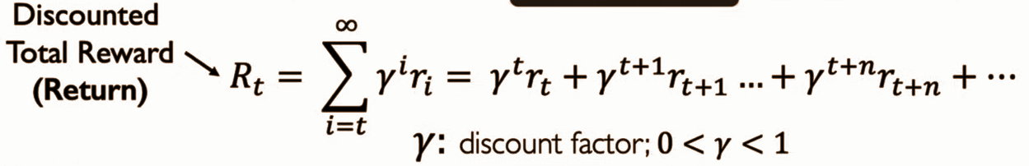Total reward has a discount factor to prioritize shorter-term rewards. This makes future rewards less valuable.

Q-Function: Returns expected total future reward in the current state by receiving a certain action.
Policy Function: Agent uses it to infer the best action in the current state.
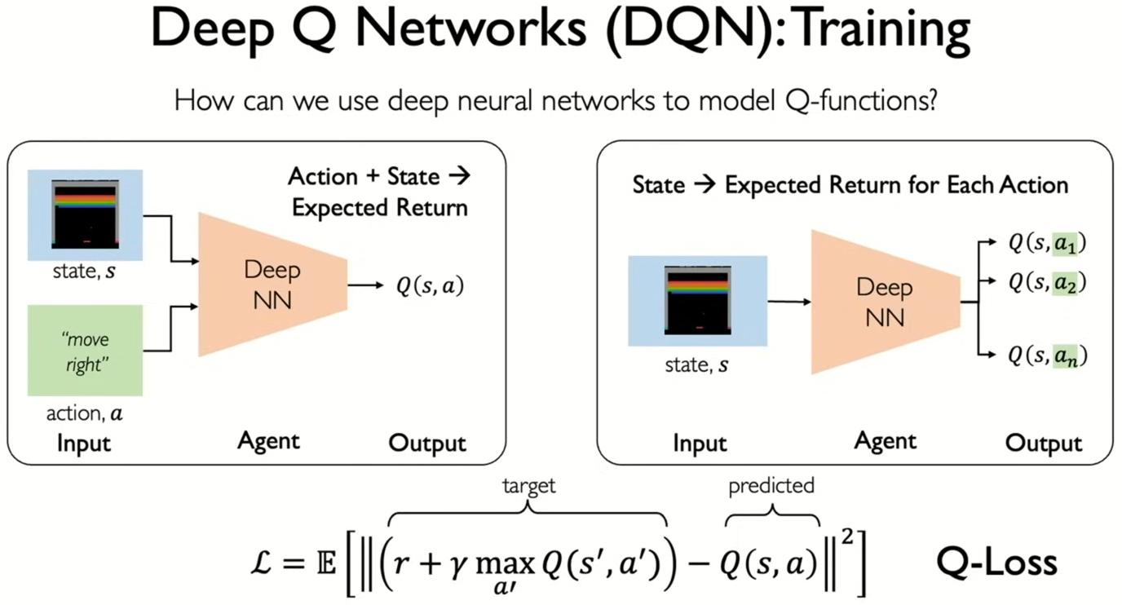
Value Learning:
Learn the Q-value. (reward)

You can either input the state & action then make it predict the Q value. Or input the state and make it predict the Q value for all possible actions.

You have a target Q-value which you use with the predicted Q-value to get Q-loss to train on.

Downsides of Q-Value (Value Learning):
- Can only model scenarios with discrete and small action spaces
- Can’t handle continuous action spaces
- Can’t learn stochastic policies (Can’t get target Q-value)

Policy Learning:
Directly trying to learn the best policy, not learning the Q function, maximizing reward. State -> expected reward for each action.

pi(s) is the policy gradient. It is the probability distribution which governs the probability that the agent should take any action given the state.

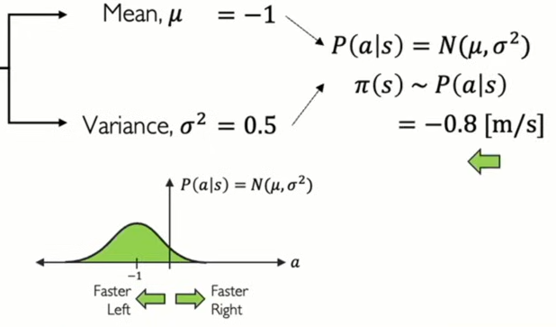
Because it’s a probability distribution, sometimes you pick the 1% move instead of the 90% likely best move, more exploration.

You can learn a continuous action space by learning the distribution of actions, not the probability of each action itself.

There is no ground truth, so you need a heuristic to apply reward. Eg. avoid the last 5 actions before a crash.

Loss = -log(Probability of action) * reward
Lower probability = more loss <- log wow!

Language Models and New Frontiers
MIT 6.S191: Language Models and New Frontiers

Universal Approximation Theorem: A feedforward network with a single layer is sufficient to approximate, to an arbitrary precision, any continuous function.

Neural Nets can perfectly fit to random data, the training set.

VAEs/GANs one-shot the output from the latent space, diffusion models iteratively refine the output to remove noise (loss?).

Diffusion works by having a training image where you gradually increase the noise. With this set you train a model to go backwards from noise to image. There are ways to add noise to discrete data like words as well.

There is no feature space limitation like VAEs/GANs.

Each denoising step introduces some stochasticity, so the same noise can generate many different images.

LLMs are extremely large. It uses cross entropy loss to compute the loss given the predicted next word and real next word.

Generative AI for Media
MIT 6.S191: (Google) Generative AI for Media

A text encoder is used to convert text to embeddings that can be inputted into the diffusion model. Text model.

